WEEK 7

REACT

1. ReactJS-HOL

Flag=true

**CODE:**

**ListofPlayers.js**

import React from 'react';

const ListofPlayers = () => {

const players = [

{ name: "Virat", score: 95 },

{ name: "Rohit", score: 65 },

{ name: "Rahul", score: 45 },

{ name: "Jadeja", score: 88 },

{ name: "Dhoni", score: 99 },

{ name: "Hardik", score: 70 },

{ name: "Bumrah", score: 60 },

{ name: "Ashwin", score: 73 },

{ name: "Shami", score: 80 },

{ name: "Gill", score: 90 },

{ name: "Kohli", score: 100 }

];

const filtered = players.filter(player => player.score < 70);

return (

<div> <h2>All Players</h2>

{players.map((p, i) => (

<p key={i}>{p.name} - {p.score}</p>

))}

<h3>Filtered Players (Score &lt; 70)</h3>

{filtered.map((p, i) => (

<p key={i}>{p.name} - {p.score}</p>

))}

</div>

);

};

export default ListofPlayers;

**IndianPlayers.js**

import React from 'react';

const IndianPlayers = () => {

const T20players = ['Virat', 'Rohit', 'Rahul'];

const RanjiPlayers = ['Pujara', 'Iyer', 'Rahane'];

const merged = [...T20players, ...RanjiPlayers];

const oddTeam = merged.filter((_, i) => i % 2 !== 0);

const evenTeam = merged.filter((_, i) => i % 2 === 0);

return (

<div>

<h2>Merged Players</h2>

{merged.map((name, i) => <p key={i}>{name}</p>)}

<h3>Odd Team</h3>

{oddTeam.map((name, i) => <p key={i}>{name}</p>)}

<h3>Even Team</h3>

{evenTeam.map((name, i) => <p key={i}>{name}</p>)}

</div>

);

};

export default IndianPlayers;

**App.js**

import React from 'react';

import ListofPlayers from './ListofPlayers';

import IndianPlayers from './IndianPlayers';

function App() {

const flag = true; // Toggle to false to switch components

return (

<div className="App">

<h1>Cricket App</h1>

{flag ? <ListofPlayers /> : <IndianPlayers />}</div>

);

}

export default App;

**OUTPUT:**

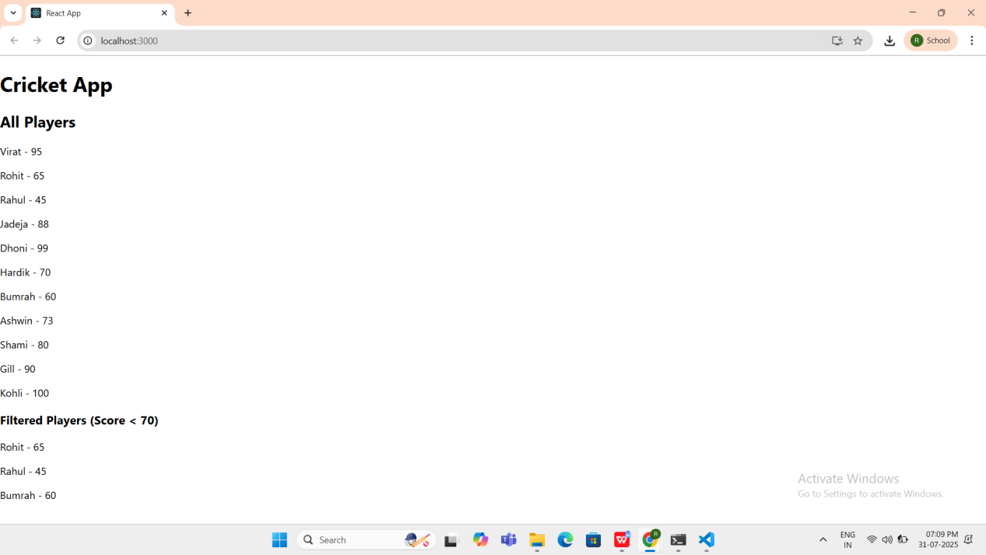

Flag=false

**CODE:**

**App.js**

import React from 'react';

import ListofPlayers from './ListofPlayers';

import Scorebelow70 from './Scorebelow70';

import OddPlayers from './OddPlayers';

import EvenPlayers from './EvenPlayers';

import ListofIndianPlayers from './ListofIndianPlayers';

function App() {

const flag = false;

const players = [

{ name: "Virat", score: 95 },

{ name: "Rohit", score: 65 },

{ name: "Rahul", score: 45 },

{ name: "Jadeja", score: 88 },

{ name: "Dhoni", score: 99 },

{ name: "Hardik", score: 70 },

{ name: "Bumrah", score: 60 },

{ name: "Ashwin", score: 73 },

{ name: "Shami", score: 80 },

{ name: "Gill", score: 90 },

{ name: "Kohli", score: 100 }

];

const T20players = ['Virat', 'Rohit', 'Rahul'];

const RanjiPlayers = ['Pujara', 'Iyer', 'Rahane'];

const IndianPlayers = [...T20players, ...RanjiPlayers];

return (

<div>

{flag === true ? (

<div>

<h1>List of Players</h1>

<ListofPlayers players={players} />

<hr />

<h1>List of Players having Scores Less than 70</h1>

<Scorebelow70 players={players} />

</div>

) : (

<div>

<div>

<h1>Indian Team</h1>

<h1>Odd Players</h1>

{OddPlayers(IndianPlayers)}

<hr />

<h1>Even Players</h1>

{EvenPlayers(IndianPlayers)}

</div>

<hr />

<div>

<h1>List of Indian Players Merged:</h1>

<ListofIndianPlayers IndianPlayers={IndianPlayers} />

</div>

</div>

)}

</div>

);

}

export default App;

**ListofPlayers.js**

import React from 'react';

const ListofPlayers = ({ players }) => {

return (

<div>

{players.map((player, i) => (

<p key={i}>{player.name} - {player.score}</p>

))}

</div>

);

};

export default ListofPlayers;

### Scorebelow70.js

import React from 'react';

const Scorebelow70 = ({ players }) => {

const filtered = players.filter(player => player.score < 70);

return (

<div>

{filtered.map((p, i) => (

<p key={i}>{p.name} - {p.score}</p>

))}

</div>

);

};

export default Scorebelow70;

**OddPlayers.js**

import React from 'react';

const OddPlayers = (IndianTeam) => {

return (

<div>

{IndianTeam.map((name, i) => (

i % 2 !== 0 ? <p key={i}>{name}</p> : null

))} </div>

);

};

export default OddPlayers;

**EvenPlayers.js**

import React from 'react';

const EvenPlayers = (IndianTeam) => {

return (

<div>

{IndianTeam.map((name, i) => (

i % 2 === 0 ? <p key={i}>{name}</p> : null

))}

</div>

);

};

export default EvenPlayers;

**ListofIndianPlayers.js**

import React from 'react';

const ListofIndianPlayers = ({ IndianPlayers }) => {

return ( <div>

{IndianPlayers.map((name, i) => (

<p key={i}>{name}</p>

))} </div>

);

};

export default ListofIndianPlayers;

**OUTPUT:**

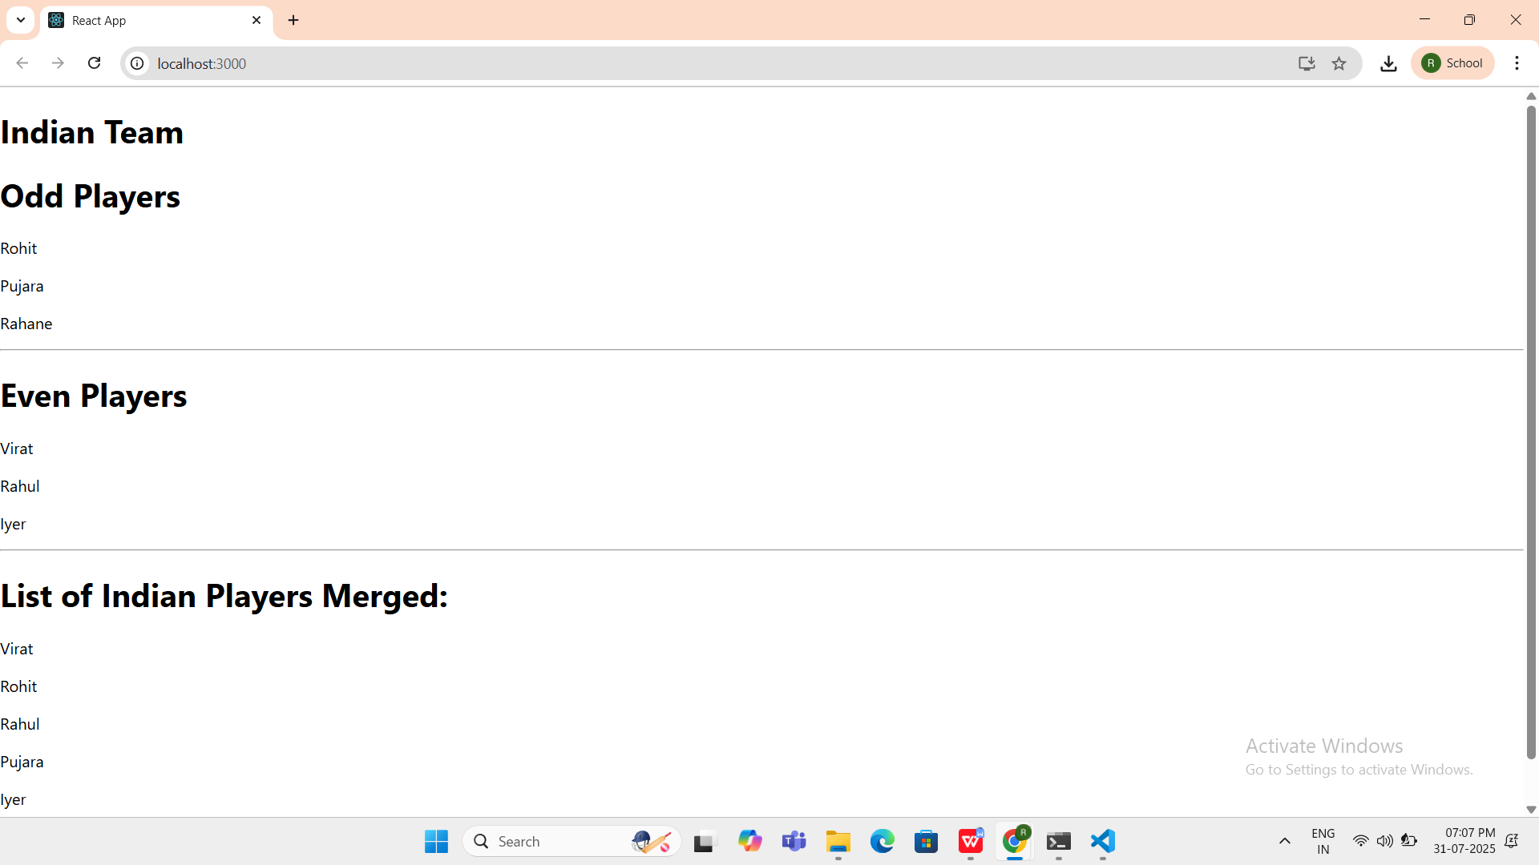

1. ReactJS-HOL

**CODE:**

**App.js**

import React from 'react';

import './App.css';

import officeImg from './office.jpg';

function App() {

const heading = <h1>Office Space Rentals - Affordable & Prime Locations</h1>;

const imageTag = <img src={officeImg} width="30%" height="30%" alt="Office" />;

const officeList = [

{ Name: "DBS", Rent: 50000, Address: "Chennai" },

];

return (

<div className="App">

{heading}

{imageTag} <h2>Available Offices:</h2>

{officeList.map((office, index) => {

const rentColor = {

color: office.Rent <= 60000 ? 'red' : 'green',

fontWeight: 'bold'

}; return (

<div key={index} style={{ marginBottom: '20px' }}>

<h3>Name: {office.Name}</h3>

<h4 style={rentColor}>Rent: Rs. {office.Rent}</h4>

<h4>Address: {office.Address}</h4>

<hr />

</div>

);

})} </div>

);

}

export default App;

**App.css**

.App {

text-align: center;

font-family: Arial, sans-serif;

padding: 20px;

background-color: #f4f4f4;

}

h1 {

color: #333;

margin-bottom: 20px;

}

h2 {

color: #444;

margin-top: 30px;

}

h3, h4 {

margin: 5px 0;

}

**OUTPUT:**

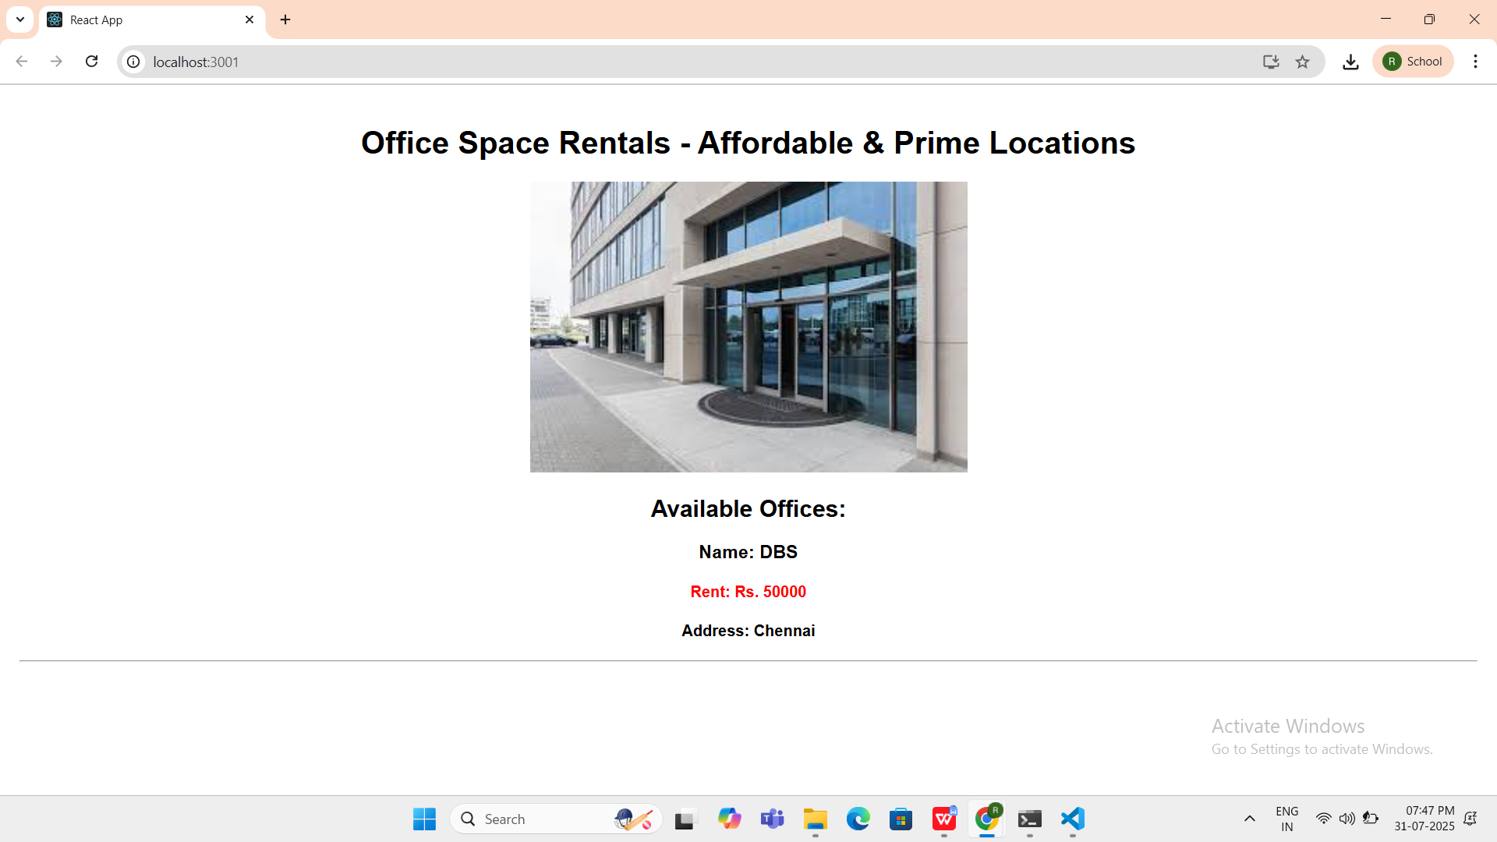

1. ReactJS-HOL

**CODE:**

**App.js**

import React, { Component } from 'react';

import CurrencyConvertor from './CurrencyConvertor';

class App extends Component {

constructor() {

super();

this.state = {

count: 0

};

this.increment = this.increment.bind(this);

this.sayHello = this.sayHello.bind(this);

}

increment() {

this.setState(prevState => ({

count: prevState.count + 1

}));

this.sayHello();

}

decrement = () => {

this.setState(prevState => ({

count: prevState.count - 1

}));

}

sayHello() {

alert("Hello! Member !! welcome.");

}

sayWelcome(msg) {

alert(msg);

}

handleSyntheticEvent = (event) => {

alert("I was clicked");

console.log("Synthetic Event:", event);

}

render() {

return (

<div style={{ textAlign: "center", marginTop: "50px" }}>

<h1>React Event Handling Example</h1>

<h2>Counter: {this.state.count}</h2>

<button onClick={this.increment}>Increment</button>{' '}

<button onClick={this.decrement}>Decrement</button>

<br /><br />

<button onClick={() => this.sayWelcome("Welcome to React!")}>Say Welcome</button>

<br /><br />

<button onClick={this.handleSyntheticEvent}>OnPress</button>

<br /><hr style={{ width: '50%' }} /><br />

<CurrencyConvertor />

</div>

);

}

}

export default App;

**CurrencyConvertor.js**

import React, { Component } from 'react';

class CurrencyConvertor extends Component {

constructor() {

super();

this.state = {

euro: '',

currency: ''

};

}

handleAmountChange = (event) => {

this.setState({ euro: event.target.value });

}

handleCurrencyChange = (event) => {

this.setState({ currency: event.target.value });

}

handleSubmit = () => {

const { euro, currency } = this.state;

if (currency.toLowerCase() === 'euro') {

const rupeeValue = (euro * 90).toFixed(2);

alert(`Converting to INR: ₹ ${rupeeValue}`);

} else {

alert('Unsupported currency. Please enter "euro".');

}

}

render() {

return (

<div style={{ marginTop: '40px', textAlign: 'center' }}>

<h2>Currency Convertor</h2>

<label>Amount:</label><br />

<input

type="number"

placeholder="Enter amount in Euro"

value={this.state.euro}

onChange={this.handleAmountChange}

/>

<br /><br />

<label>Currency:</label><br />

<input

type="text"

placeholder="Enter currency"

value={this.state.currency}

onChange={this.handleCurrencyChange}

/>

<br /><br />

<button onClick={this.handleSubmit}>Submit</button>

</div>

);

}

}

export default CurrencyConvertor;

**OUTPUT:**

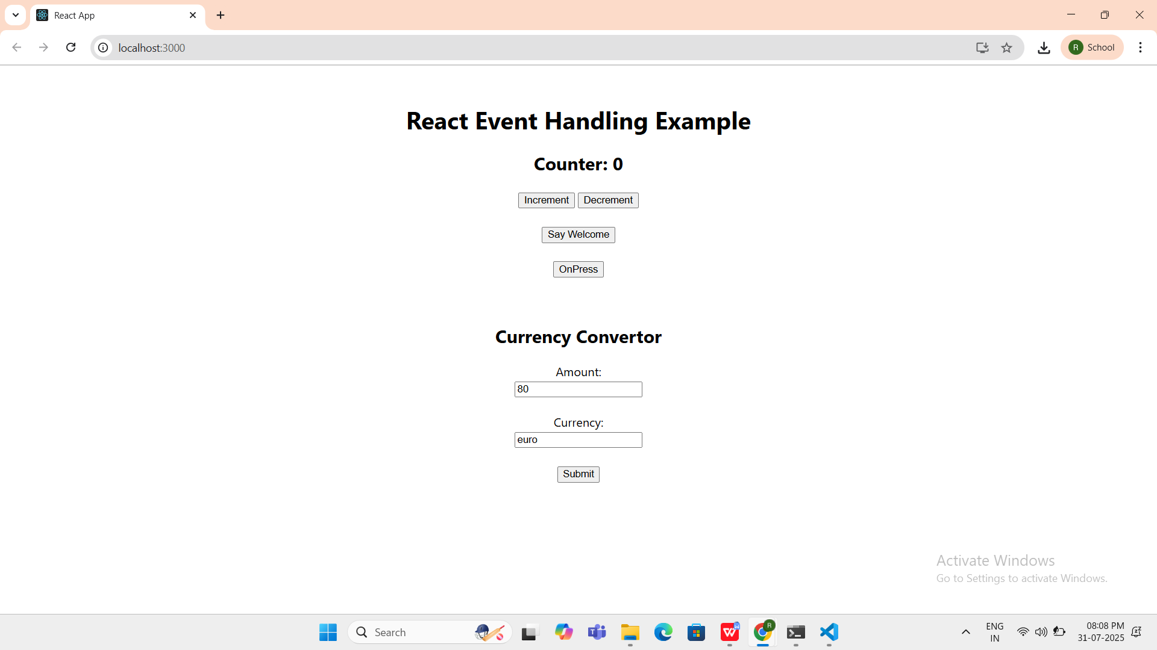

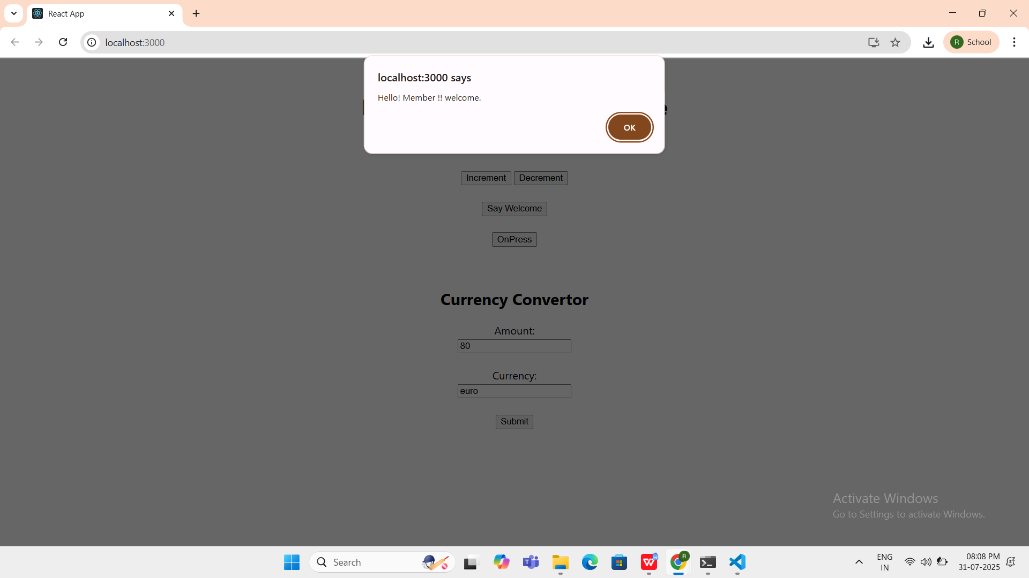

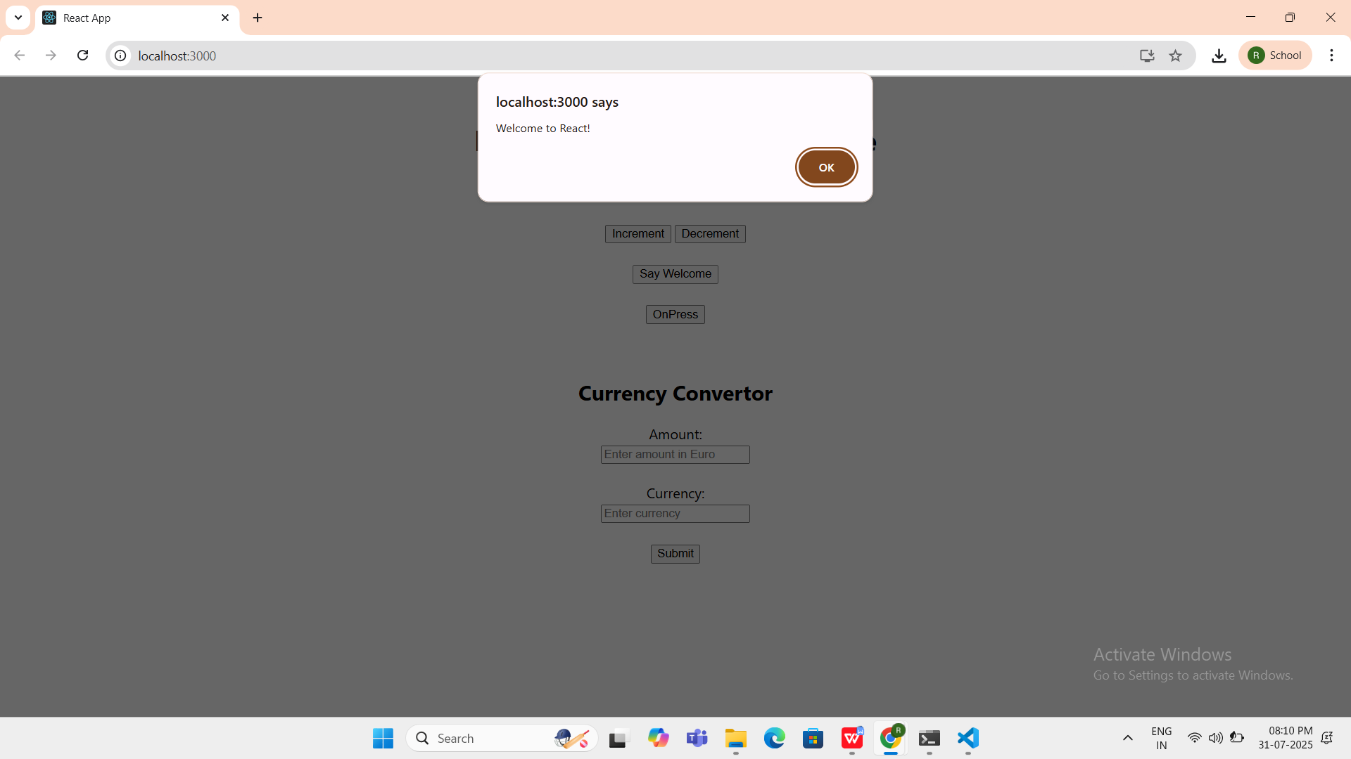

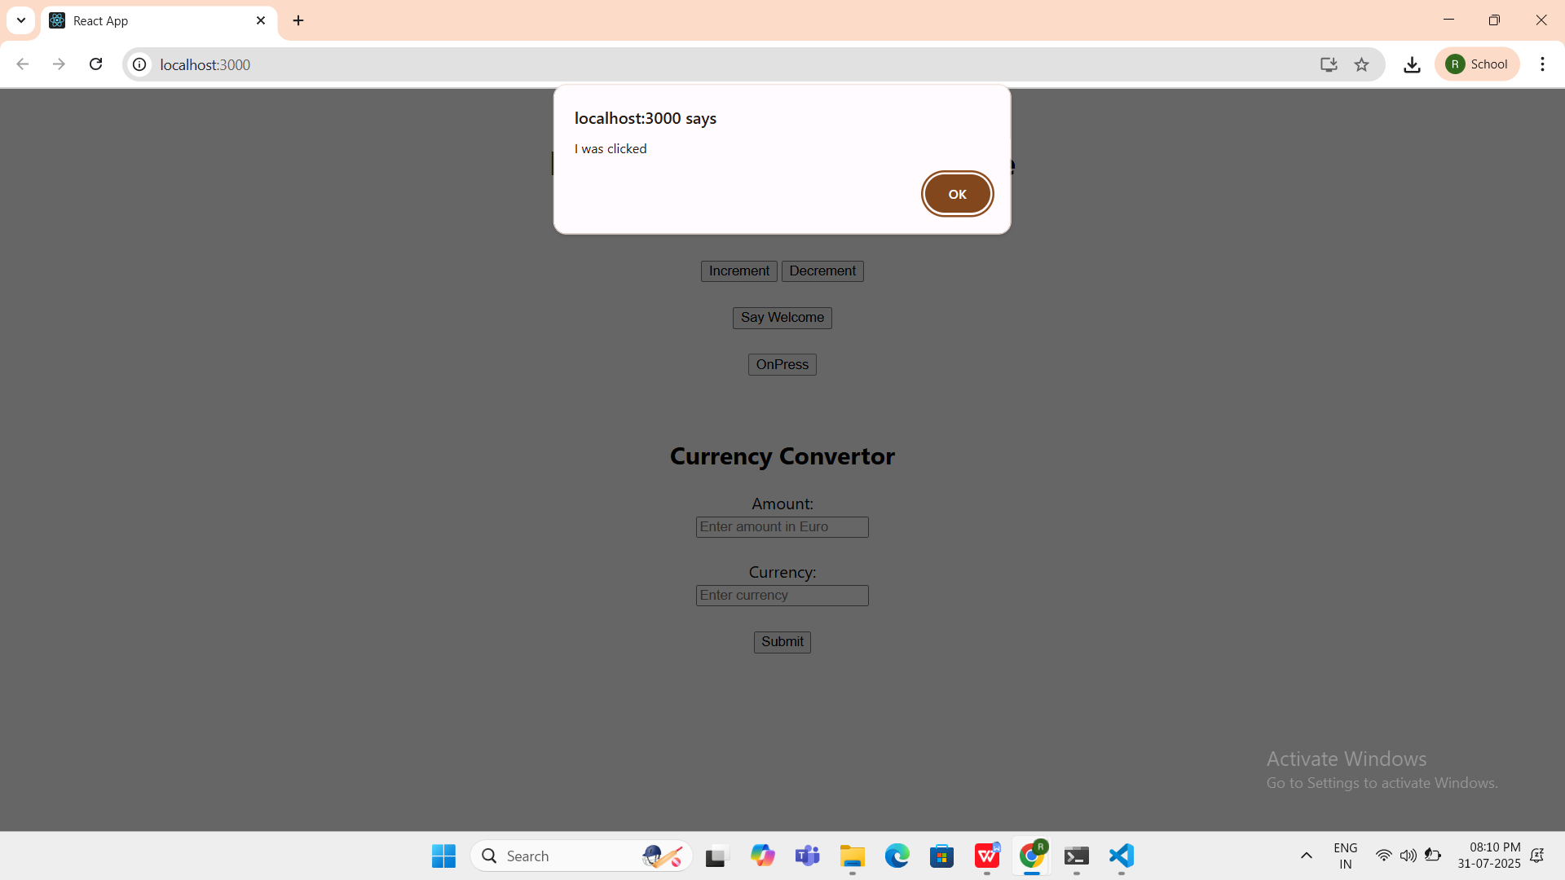

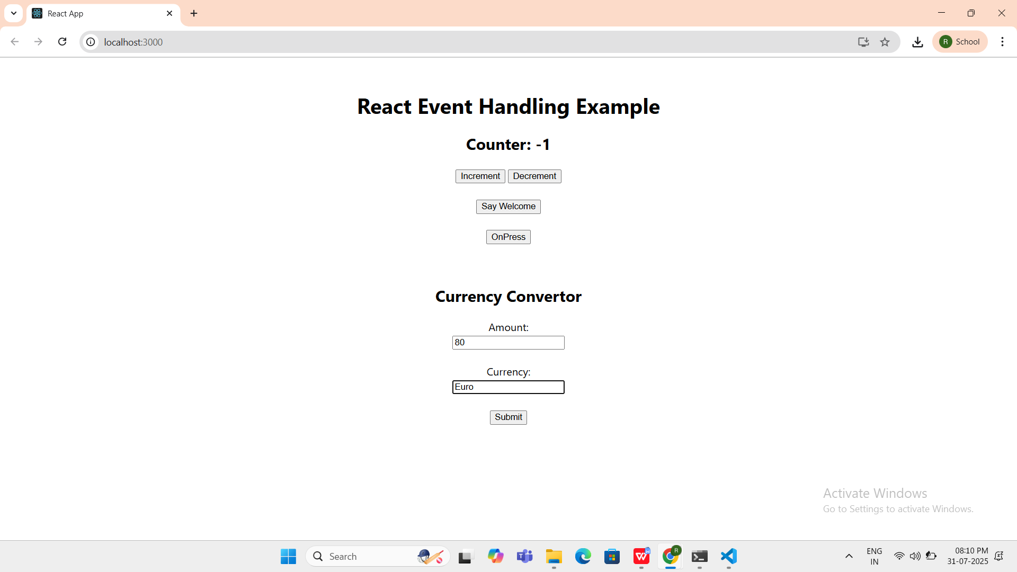

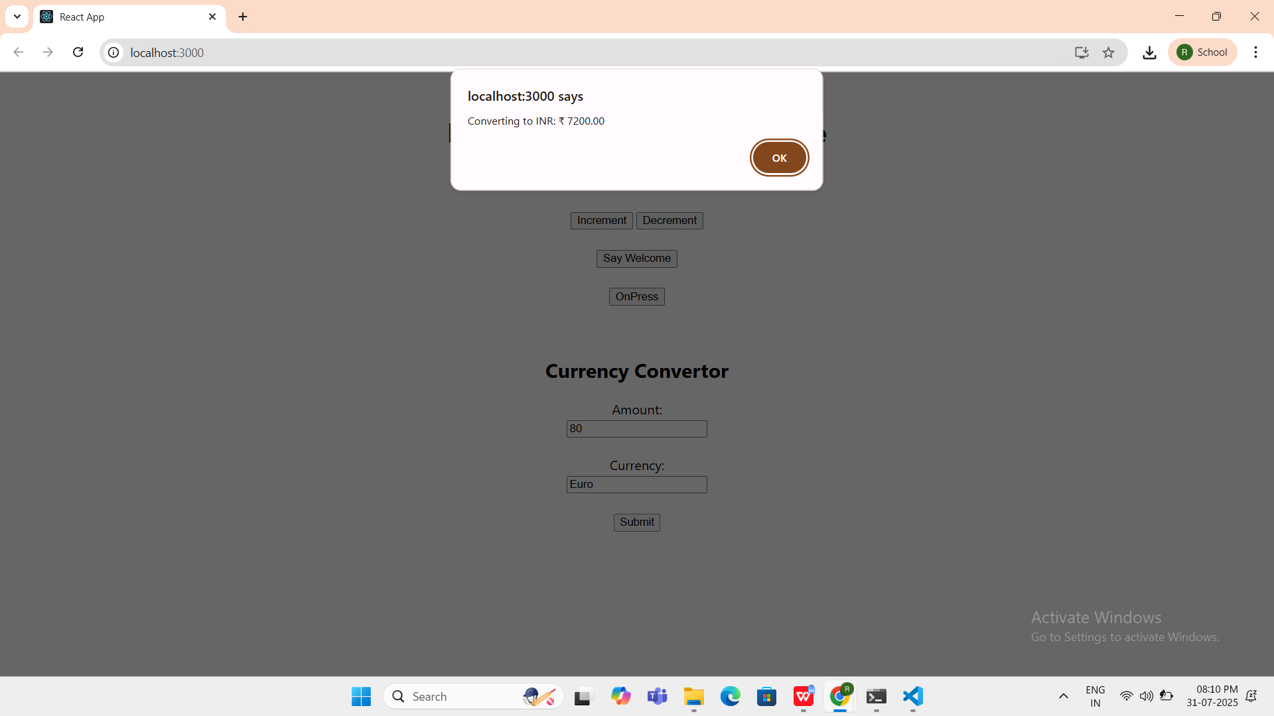

1. ReactJS-HOL

**CODE:**

**GuestPage.js**

import React from 'react';

function GuestPage() {

return (

<div>

<h2>Please Sign Up</h2>

<p>Available Flights:</p>

<ul>

<li>Flight A101 – Chennai ➝ Bangalore</li>

<li>Flight B202 – Delhi ➝ Mumbai</li>

<li>Flight C303 – Hyderabad ➝ Kolkata</li>

</ul>

</div>

);

}

export default GuestPage;

**UserPage.js**

import React from 'react';

function UserPage() {

return (

<div>

<h2>Welcome Back!</h2>

<p>You are now logged in. Book your flight:</p>

<button>Book Ticket</button>

</div>

);

}

export default UserPage;

**App.js**

import React, { Component } from 'react';

import GuestPage from './GuestPage';

import UserPage from './UserPage';

class App extends Component {

constructor() {

super();

this.state = {

isLoggedIn: false

};

}

handleLogin = () => {

this.setState({ isLoggedIn: true });

}

handleLogout = () => {

this.setState({ isLoggedIn: false });

}

render() {

let content;

let button;

if (this.state.isLoggedIn) {

content = <UserPage />;

button = <button onClick={this.handleLogout}>Logout</button>;

} else {

content = <GuestPage />;

button = <button onClick={this.handleLogin}>Login</button>;

}

return (

<div style={{ textAlign: 'center', marginTop: '40px' }}>

<h1>Ticket Booking App</h1>

{button}

<hr style={{ width: '50%' }} />

{content}

</div>

);

}

}

export default App;

**OUTPUT:**

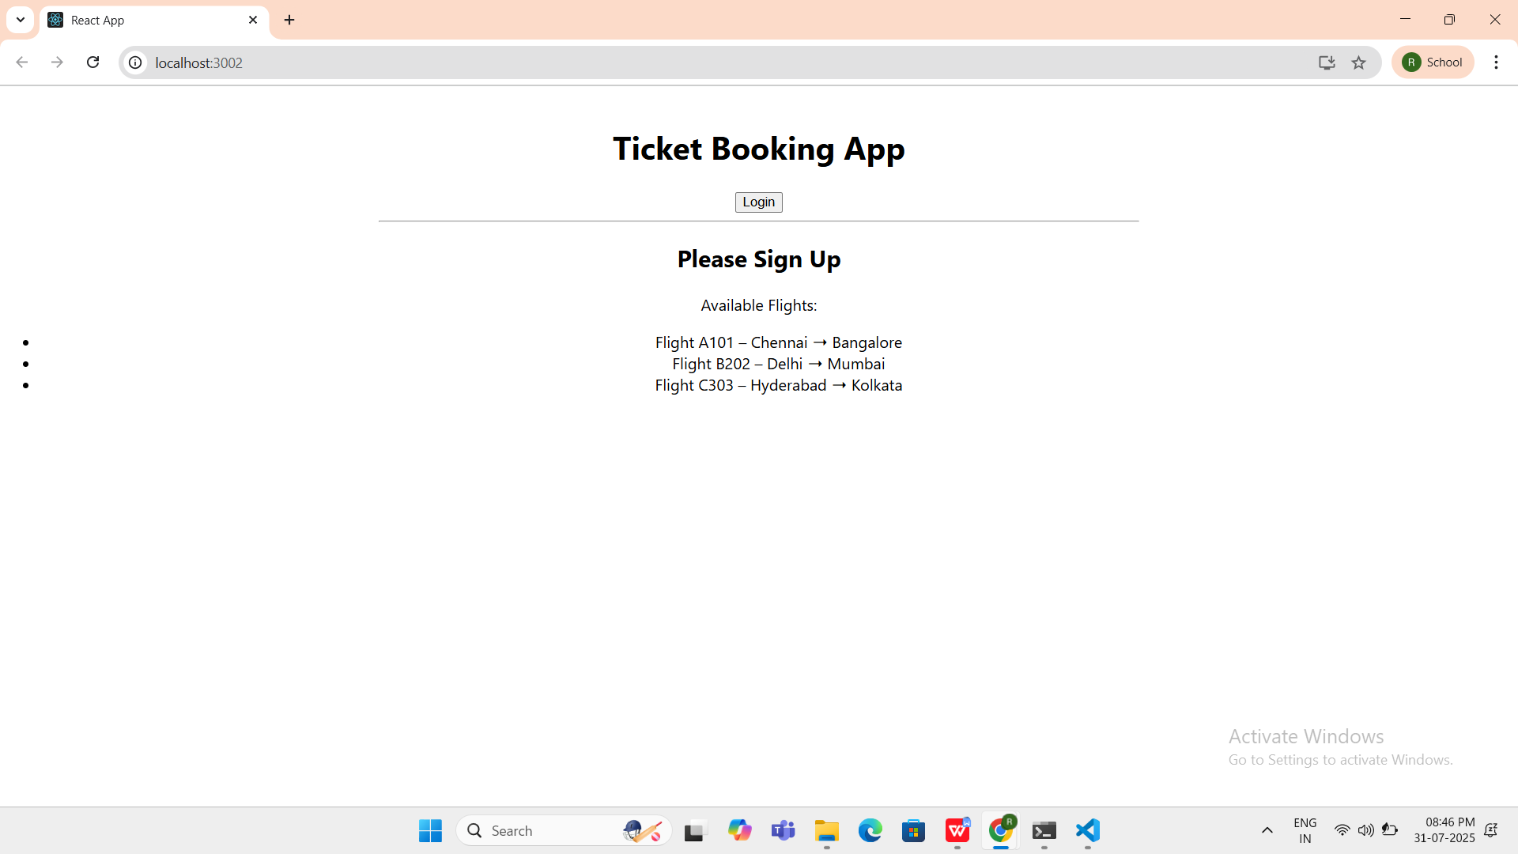

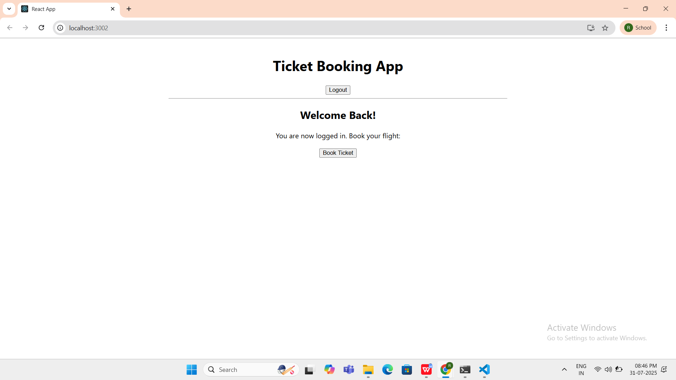

1. ReactJS-HOL

**CODE:**

**App.js**

import React, { Component } from 'react';

import BookDetails from './BookDetails';

import BlogDetails from './BlogDetails';

import CourseDetails from './CourseDetails';

class App extends Component {

constructor() {

super();

this.state = {

selected: 'book' // 'book', 'blog', or 'course'

};

}

renderComponent() {

if (this.state.selected === 'book') {

return <BookDetails />;

}

return this.state.selected === 'blog'

? <BlogDetails />

: <CourseDetails />; // Way 3: Default

}

render() {

const { selected } = this.state;

let title;

if (selected === 'book') {

title = <h1>Book Section</h1>;

} else if (selected === 'blog') {

title = <h1>Blog Section</h1>;

} else {

title = <h1>Course Section</h1>;

}

return (

<div style={{ textAlign: 'center', marginTop: '40px' }}>

<h2>Blogger App</h2>

<div>

<button onClick={() => this.setState({ selected: 'book' })}>Show Book</button>

<button onClick={() => this.setState({ selected: 'blog' })}>Show Blog</button>

<button onClick={() => this.setState({ selected: 'course' })}>Show Courses</button>

</div>

<hr />

{title}

{this.renderComponent()}

{/* Way 5: Logical AND conditional rendering */}

{selected === 'book' && <p>You're viewing Book Details.</p>}

</div>

);

}

}

export default App;

**CourseDetails.js**

import React from 'react';

function CourseItem({ course }) {

return (

<li key={course.id}>

{course.name} - {course.instructor}

</li>

);

}

function CourseDetails() {

const courseList = [

{ id: 1, name: 'React Basics', instructor: 'Andrew Clark' },

{ id: 2, name: 'Advanced React', instructor: 'Dan Abramov' },

{ id: 3, name: 'React with TypeScript', instructor: 'Sunil Pai' }

];

return (

<div>

<h2>Course Details</h2>

<ul>

{courseList.map(course => (

<CourseItem key={course.id} course={course} />

))}

</ul>

</div>

);

}

export default CourseDetails;

**BlogDetails.js**

import React from 'react';

function BlogDetails() {

return (

<div>

<h2>Blog Details</h2>

<p>Topic: Understanding Conditional Rendering</p>

<p>Author: Sophie Alpert</p>

</div>

);

}

export default BlogDetails;

**BookDetails.js**

import React from 'react';

function BookDetails() {

return (

<div>

<h2>Book Details</h2>

<p>Title: React Fundamentals</p>

<p>Author: Dan Abramov</p>

</div>

);

}

export default BookDetails;

**OUTPUT:**

